TYPES OF WORRY

There is more than one type of worry. Sometimes worry can be helpful and beneficial, but other times it can be unhelpful. In times of uncertainty it can be difficult to differentiate between actionable concerns and worries that waste our mental energy.

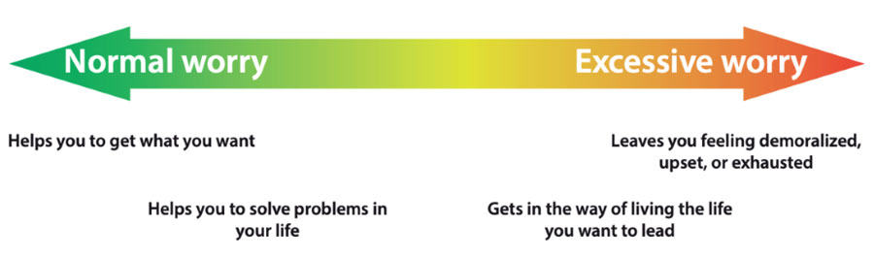

Refer to these decision-making points when considering how to categorise your worries:

Real Worries (Helpful)
- A worry that can be related to a real situation
- A worry about an event that is current
- A worry that can take action or be problem solved

Hypothetical Worries (Unhelpful)
- A worry about an event from the past
- A worry about something that does not exist
- A worry about something has not actually happened but might happen in the future
- A “what if…..” statement
- A worry that has no action
- A worry that we have no control over

