Relaxation for Younger Children

With each action tense the specific body part for 10 seconds and then release slowly for 5 seconds.

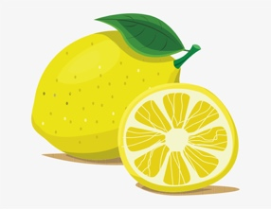 | Hands & Arms  Pretend you are squeezing a whole lemon in your left hand. Squeeze it hard. Try to squeeze all the juice out. Feel the tightness in your hand and arm as you squeeze. Now drop the lemon and relax. See how much better your hand and arm feel when they are relaxed. Repeat with other hand.
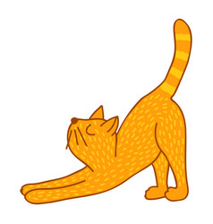 | Arms and Shoulders  Pretend you are a furry, lazy cat. You want to stretch. Stretch your arms out in front of you. Raise them up high over your head. Way back. Feel the pull in your shoulders. Stretch higher. Now just let your arms drop back to your side. Okay kitten, stretch again. Repeat.
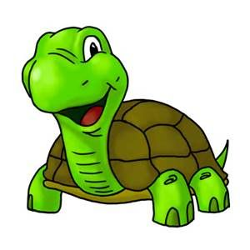 | Shoulder and Neck  Now pretend you are a turtle. You’re sitting out on a rock by a nice, peaceful pond, just relaxing in the warm sun. It feels nice and warm and safe here. Oh-Oh! You sense danger. Pull your head into your house. Try to pull your shoulders up to your ears and push your head down into your shoulders. Hold in tight. It isn’t easy to be a turtle in a shell. The danger is past now. You can come out into the warm sunshine and once again you can relax and feel the warm sunshine. Watch out now. More danger. Hurry pull your head back into your house and hold it tight. Repeat.
Jaw
You have a giant jawbreaker bubble gum in your mouth. It’s very hard to chew. Bite down on it. Hard! Let your neck muscles help you. Now relax. Just let your jaw hang loose. Notice how good it feels just to let your jaw drop. Okay, let’s tackle that jawbreaker again now. Repeat.
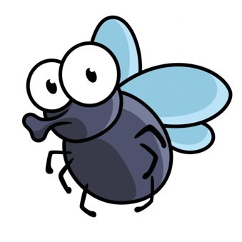 | Face and Nose  Here comes a pesky old fly. He has landed on your nose. Try to get him off without using your hands. That’s right, wrinkle up your nose. Make as many wrinkles in your nose as you can. Scrunch your nose up real hard. Good. You’ve chased him away. Now you can relax your nose. Oops here he comes back again. Repeat.

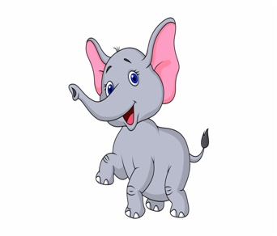 | Stomach  Hey! Here comes a cute baby elephant. But he’s not watching where he’s going. He doesn’t see you lying there in the grass, and he’s about to step on your stomach. Don’t move. You don’t have time to get out of the way. Just get ready for him. Make your stomach very hard. Tighten up your stomach muscles real tight. Hold it. It looks like he is going the other way. You can relax now. Let your stomach go soft. Let it be as relaxed as you can. That feels so much better. Oops, he’s coming this way again. Get ready. Repeat.
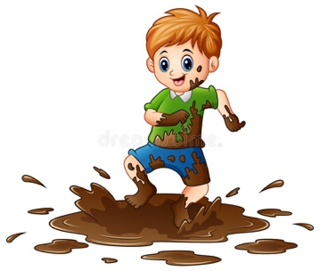 | Legs and Feet  Now pretend that you are standing barefoot in a big, fat mud puddle. Squish your toes down deep in to the mud. Try to get your feet down to the bottom of the mud puddle. Push down, spread your toes apart, and feel the mud squish up between your toes. Now step out of the mud puddle. Relax your feet. Let your toes go loose and feel how nice that is. It feels good to be relaxed. Repeat...

