WHY DO I FEEL LONELY?

Loneliness is a feeling that most people will have at some point in their lives. Even when people are with others they can sometimes feel detached, alienated or isolated. There can be many reasons for this.
I feel left out from my friends, family or community

I feel like I don’t fit in, valued or accepted by others

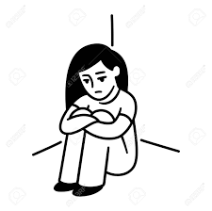

I don’t feel happy with who I am
I don’t feel like I’m understood

I feel afraid to speak up and worry what others think

I no longer spend time with someone close to me

